 | 16.1.6 Editors - Dope Sheet - Channel Menu

Table of content
Dopesheet Editor - Channel Menu 1
Channel Menu - Dope sheet + Action Editor mode 2
Delete Channels 2
Group Channels 2
Ungroup Channels 2
Channel Settings 2
Toggle Channel Editability 3
Extrapolation Mode 3
Constant Extrapolation 3
Linear Extrapolation 3
Make Cyclic 3
Clear Cyclic 3
Expand Channels 3
Collapse Channels 3
Move 3
Revive Disabled F-Curves 3
Frame Selected Channels 3
Discontinuity (Euler Filter) 3
Channel Menu - Grease Pencil mode 4
Delete Channels 4
Channel Settings 4
Move 4

Dopesheet Editor - Channel Menu
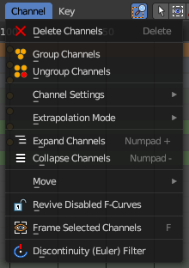
This menu contains functionality to manage the channels in the channels list at the left.
The menu doesn't exist in all modes. It exists in Dope sheet, Action Editor and Grease Pencil mode. And has different content.

Channel Menu - Dope sheet + Action Editor mode

Delete Channels
Deletes the selected channels and all its keyframes.

Group Channels
Creates a custom group from the selected channels.
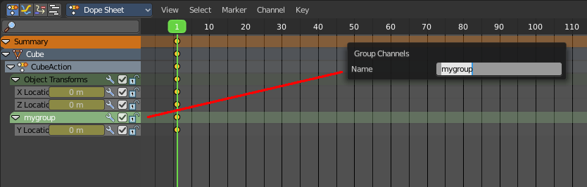

Ungroup Channels
Removes the selected channels from the group, and adds them back to the original hierarchy.

Channel Settings
Adjusts the locks and check boxes in the channels list from outside of the channels list for all selected elements at once. With Toggle Mute you could, for example, disable all selected channels at once.
The menu items should be self explaining.
These are also accessible from the Dopesheet Channel Context Menu.
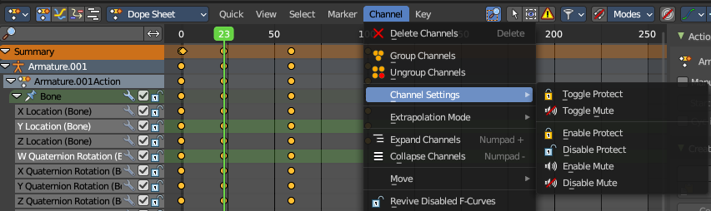

Toggle Channel Editability
Toggles the locks in the channel list from their previous state to locked and back.

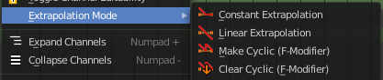
Extrapolation Mode
Sets the extrapolation mode for the selected F-Curves. Means how the curve acts at the beginning and the end of the F-Curve.

Constant Extrapolation
The animation curve continues straight at the end.

Linear Extrapolation
The animation curve continues the last direction.

Make Cyclic
Makes the animation loopable. The interpolation curves are adjusted so that the first frame fits to the last frame.

Clear Cyclic
Removes the cyclic extrapolation.

Expand Channels
Expands all channels in the channel list.

Collapse Channels
Collapses all channels in the channels list.

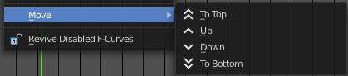
Move
Sort the items in the channels list.

Revive Disabled F-Curves
Clears the disabled tag from all f-curves to get broken F-Curves working again.
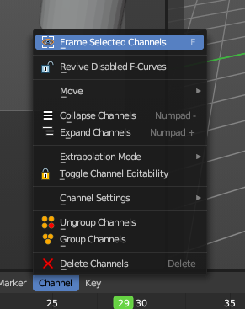

Frame Selected Channels
Resets the viewable area to show the selected channel keyframes. This will change the zoom to fit all in the selected chanel.

Discontinuity (Euler Filter)
Fix large jumps and flips in the selected Euler Rotacion F-Curves arising from the rotation values being clipped when baking physics.
This operator only affects Euler rotation animation.

Channel Menu - Grease Pencil mode

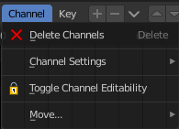
Delete Channels
Deletes the selected channels and all its keyframes.

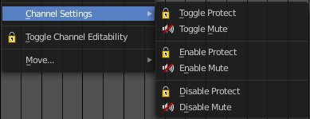
Channel Settings
Adjust the locks and check boxes in the channels list from outside of the channels list for all selected elements at once. With Toggle Mute you could for example disable all selected channels at once.
The menu items should be self explaining.
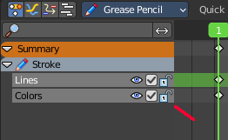

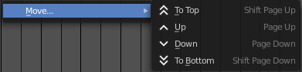
Move
Sort the items in the channels list.

